**Seed Sanitization and *Escherichia coli* inoculation in the microbiome of Red Romaine Lettuce (*Lactuca sativa* cv. ‘Outredgeous’)**

Kayla J. Quintero1, Anirudha R. Dixit, Christina L. M. Khodadad, Mary E. Hummerick, Cory J. Spern, LaShelle E. Spencer, Jason A. Fischer, Aaron B. Curry, Jennifer L. Gooden, Gretchen J. Maldonado Vazquez, Raymond M. Wheeler, Gioia D. Massa & Matthew W. Romeyn

1Corresponding author: kquinter@purdue.edu

Department of Horticulture and Landscape Architecture, Purdue University, West Lafayette, Indiana, 47907, USA

NASA UB, Kennedy Space Center, Merritt Island, FL, USA

**Abstract**

Background: Chemical seed sanitization is a process used to reduce the abundance of microbes on the surface of seeds. Although this is intended to remove plant and human pathogens from crop plants grown on the International Space Station, the process inadvertently and unavoidably removes beneficial microbes as well. To determine the impact of seed sanitization on the plant microbiome, sanitized and unsanitized seeds from red Romaine lettuce (Lactuca sativa cv. ‘Outredgeous’) were exposed to *Escherichia coli* and grown in controlled environment growth chambers simulating environmental conditions aboard the International Space Station. Plants were harvested at four 7-day intervals from 7 days post-germination to maturity (28 days). The bacterial communities of leaf and root were investigated using the 16S rRNA sequencing.

Results: Analyses of alpha diversity in pairwise comparisons show difference between sanitization groups and between samples from different days after planting. Analyses of beta diversity show similar results. Some differential abundance tests show no differential abundance, while others show statistical difference in abundance of various taxa between sanitization groups and E. coli treatment groups. There is a differential abundance of several metabolic pathways between sanitization groups and between E. coli treatment groups as well. Network analyses show more cooccurrences of taxa in unsanitized samples than sanitized samples.

Conclusions: Seed sterilization may have the effect of decreasing beta and alpha diversity in the roots and leaves of crop plants on the ISS, as well as relative abundance of several taxa. E. coli treatment may also have an effect on the abundance of several taxa, but not on the alpha or beta diversity between treatments. Number of days after planting is likely to have a greater effect on the alpha and beta diversity of microbial communities on leaves and roots than E. coli treatment.

Keywords: Microbiome, Red Romaine lettuce, Phyllosphere, Rhizosphere, E. coli, Seed surface sanitization

**Background**

Deep space exploration is a relatively short-term goal of the National Aeronautics and Space Administration (NASA). A manned trip to Mars is currently projected to last about 7 months, during which astronauts face several physical and emotional challenges. One of these challenges is the quick degradation of vitamin C in pre-prepared meals for astronauts. Like most primates, humans lack the capacity to produce our own vitamin C. Therefore, in order to prevent scurvy, astronauts on long-duration missions with little opportunity for resupply must be equipped with a safe and reliable means to produce and consume vitamin C; the astronauts must grow (at least some of) their own food.

Growing plants in space is not without its difficulties. Up until now, most of the crops we have managed to grow successfully in space have been leafy greens. We selected the red romaine cultivar “Outredgeous” for this study because it is regularly successfully grown in on the International Space Station (ISS) [4], so it is a clear choice for use in deep-space missions. Traditionally, seeds are sanitized before being sent to the ISS for growth, harvest, and consumption. The intention behind sterilizing seeds is to minimize the introduction of plant and human pathogens into the ISS, but sterilizing does not discriminately remove pathogens. The source of the plant microbiome is provided by the seed via vertical transmission [1]. Besides the presence of microbes that are introduced through handling by astronauts, the microbiome of mature plants is expected to be very similar to the microbiome of seeds when grown in ISS-like conditions. Sterilization of seeds may have an effect on the microbiome of the mature plant, which may affect plant growth and subsequently limit the amount of fresh produce the astronauts are able to grow.

Alternatively, food safety is critical. Researchers around the world depend on astronauts to conduct experiments for them while in space. These experiments are most often extremely delicate and time sensitive. They cannot afford for an astronaut to take a sick day. Seed sterilization is considered essential to the prevention of food borne illnesses on the ISS, but while it may remove most or even all pathogens from a seed, it cannot ensure that a plant remains sterile in an unsterile environment like the ISS.

The aim of this study was to investigate the effects of seed sterilization and post-sterilization inoculation of a food-borne pathogen on the root and leaf microbiome of a crop commonly grown on the ISS in order to improve the space crop production processes currently used by NASA for astronauts aboard the ISS.

**Methods**

Experimental Design

The experimental design of this study was multi-faceted. Only one crop was tested (red romaine lettuce cv. Outredgeous) and variables included seed sanitization (sanitized or unsanitized), E. coli treatment (treated or untreated), and days after planting (7, 14, 21, and 28). Samples for testing included leaf and root tissues, and seed samples were taken before planting for comparison.

Seed Sanitization

Seeds were batch sanitized by adding 0.5ml HCl to 30ml bleach in a jar and placing 75-100 seeds on a petri dish into the jar. The jar was sealed for 1 hour, then opened and off-gassed for 24 hours in a fume food. To confirm sanitization, 5 seeds were plated onto each of 2 plates of trypticase soy agar (TSA) and 2 plates of inhibitory mold agar (IMA), 20 seeds total. Plates were incubated at 30C for 24-48 hours for TSA and up to 5 days for IMA, observed daily.

Seed Inoculation

Seeds were prescreened for E. coli using 16S rRNA sequencing and determined to be E. coli – free prior to sanitization and inoculation. A culture of 10^6 E. coli cells/ml was prepared in trypticase soy broth (TSB) and in a shaking incubator at 30C for 16 hours. 25 sterilized seeds and 25 unsterilized seeds were inoculated by submerging into the culture. The rest of the seeds were submerged in sterile TSB. Inoculation occurred at room temperature just prior to planting.

Cultivation and Harvest

Four seeds, from a single treatment group, were planted in 10cm square pots filled with 500ml arcillite and 7.5 g/l time-release fertilizer. They were germinated and grown in growth chambers under similar conditions to the ISS: 50% relative humidity, 300ppm CO2, 23C, and a photoperiod of 16 hours light and 8 hours dark under fluorescent lights. Plants from the same treatment group were kept on a single tray and bottom-watered with DI water on an automated system, monitored daily. Pots were thinned at 7 days to 1 plant each. Leaf and root samples for microbiome analysis were taken using aseptic techniques from three plants per treatment, chosen at random, every 7 days.

16S PCR and Sequencing

PCR was completed using custom barcode 16S rRNA gene V4 region primers. The final PCR master mix contained 1X PCR buffer, 2.25mM MgCl2, 300nM dNTPs, 300nM forward and reverse primers, and 0.25units of Platinum Taq polymerase. Each reaction was completed in duplicate with 1 ng of DNA. Samples were denatured at 95C for 5 minutes, then 30 cycles at 95C for 1 minute, 58 C for 1 minute, and lastly 72C for 2 minutes. A final elongation step was completed at 72C for 10 minutes. Replicates of each reaction were combined and cleaned to remove excess primers and dNTPs. Amplicon concentration was determined and nanomolar concentration calculated for each sample. Samples were diluted to 4nM and an equimolar concentration library was created. A 10% PhiX aliquot was added to the library, then the library was sequenced on the Illumina MiSeq platform (Illumina Inc., San Diego, CA, United States) with a 500-cycle V2 kit with 250-bp paired ends and FASTQ reads at >30 quality score.

Sequencing Data Analysis

Data generated from sequencing samples were analyzed using QIIME2 (ver. 2023.9). Demultiplexed sequences were imported into the DADA2 de-noising algorithm. Forward reads were truncated to 190 and reverse reads were truncated to 180 bases to remove low quality reads. Taxonomies were assigned using the greengenes database. Sequences associated with chloroplasts and mitochondria were removed. For alpha and beta diversity analysis, a subsampling depth of 1250 was selected because it was the largest number that would not remove many seed samples while leaving comparable quantities of samples in either of the groups within each variable and because most of the alpha rarefaction curves produced leveled off at this point, indicating that very few taxa would be left out using this depth. Taxa bar plots were produced in R. Differential abundance analysis was carried out for taxa with ANCOM, ANCOMBC, and DESeq2 using QIIME2 and cooccurrence using R. Differential abundance analysis for genes was carried out with a cooccurrence analysis in R and the resulting network was mapped in Cytoscape.

Statistical Analysis

Alpha diversity was determined using Faith’s phylogenetic diversity, Shannon index, Pielou’s evenness, and observed features diversity indices. Kruskal-Wallace group significance and pairwise comparison significance were calculated in QIIME2.

Beta diversity was determined using Bray-Curtis dissimilarity, Jaccard, weighted unifrac, and unweighted unifrac diversity indices. PERMANOVA group significance and pairwise comparison significance was calculated in QIIME2.

**Results**

Kruskal-Wallis pairwise comparisons showed a statistically significant difference in alpha diversity between sanitized and unsanitized samples, 7- and 14-day samples, and 14- and 21-day samples (Fig. 2). PERMANOVA statistical analysis showed a statistically significant difference in beta diversity between sanitized and unsanitized samples and between 21- and 28-day samples (Fig. 7). ANCOM analysis resulted in no differentially abundant taxa between sanitization groups or between E. coli treatment groups (Fig. 9). DESeq2 differential abundance plots show an over representation of more taxa in not sanitized samples and treated samples than in sanitized samples and not treated samples, respectively (Fig. 10). Network analyses show more cooccurrences between taxa in not sanitized samples than in sanitized samples (Fig. 11). Differential abundance analysis of metabolic pathways shows two pathways overrepresented and one underrepresented in sanitized samples, as well as six pathways overrepresented and one underrepresented in samples treated with E. coli (Fig. 12).

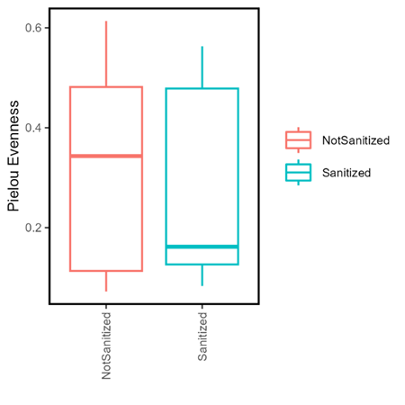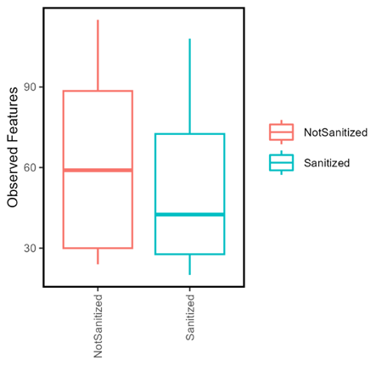

Figure 1. Alpha diversity box plots of Not Treated vs. Treated samples (left two) and Not Sanitized vs Sanitized (right two) using Pielou’s Evenness and Observed Features diversity metrics, respectively.

|  |  |  |  |  |
| --- | --- | --- | --- | --- |
| Kruskal-Wallis Pairwise Significance (significant findings only) | | | | |
| Alpha Diversity Metric | Group 1 | Group 2 | H | p-value |
| Evenness | 14 days | 21 days | 4.5741 | 0.0325 |
| Shannon | 7 days | 14 days | 4.9150 | 0.0266 |
| PD | Sanitized | Unsanitized | 5.4642 | 0.0194 |

Figure 3. Table of Kruskal-Wallis pairwise significance metrics calculated for three compared pairs. All possible pairwise comparisons were made using each of the four alpha diversity metrics, but only pairwise comparisons resulting in a p-value < 0.05 are listed here.

Figure 4. Ordination plot comparing Sanitized and Not Sanitized samples made using the Bray-Curtis dissimilarity index and colored according to sample tissue type.

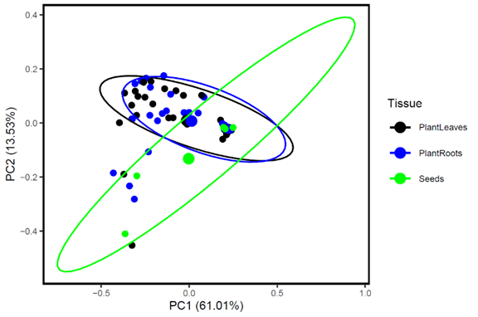

Figure 5. Ordination plot including all samples made using the Bray-Curtis dissimilarity index and colored according to sample tissue type.

|  |  |  |  |  |  |  |
| --- | --- | --- | --- | --- | --- | --- |
| PERMANOVA Pairwise Results (significant findings only) | | | | | | |
| Beta Diversity  Metric | Variable | Group 1 | Group 2 | Pseudo-F | p-value | q-value |
| Unweighted Unifrac | Sanitization | Sanitized | Unsanitized | 2.6522 | 0.037 | 0.037 |
| Weighted Unifrac | Age At Harvest | 21 days | 28 days | 3.4067 | 0.050 | 0.500 |

Figure 7. Table of PERMANOVA results for pairwise comparisons using weighted and unweighted unifrac diversity metrics. All possible pairwise comparisons were made using each beta diversity metric, but only pairwise comparisons resulting in a p-value < 0.05 are listed here.

Figure 8. Taxa bar plots constructed using genus that were present in at least 2% of each sample on average in each of the two sanitization treatment groups and in each of the two *E.coli* treatment groups, respectively.

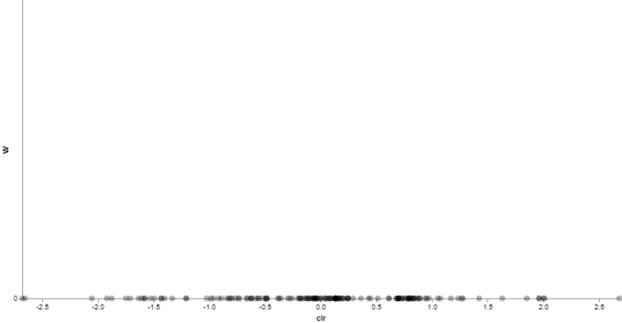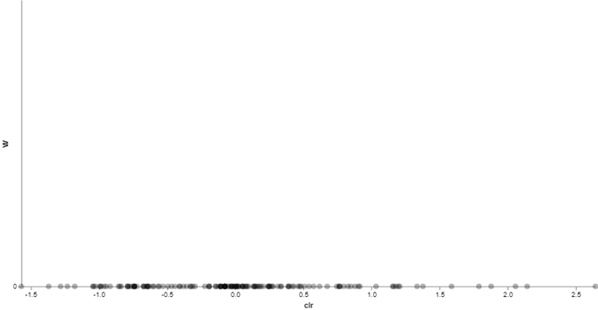

Figure 9. Volcano plots from ANCOM analysis for E. coli treatment groups (above) and seed sanitization groups (below).

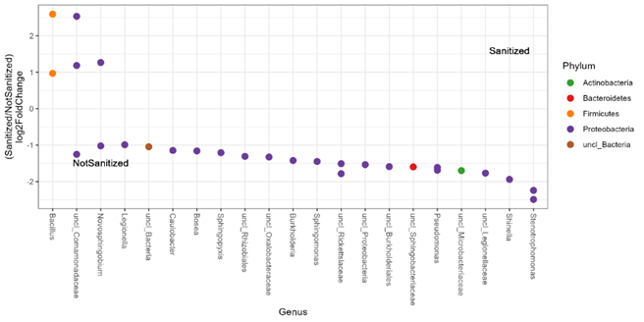

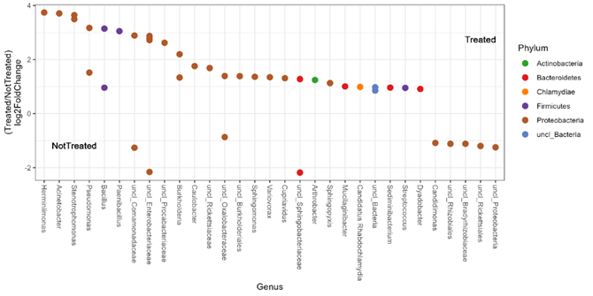

Figure 10. Plots of differentially abundant genus between seed sanitization groups (above) and E. coli treatment groups (below) colored by phyla, as calculated by DESeq2.

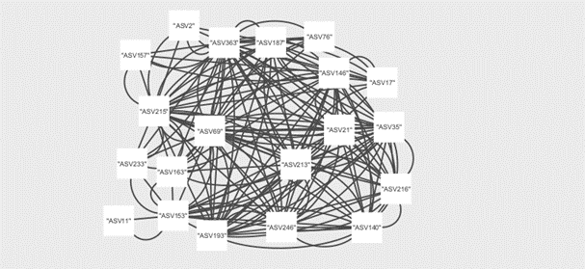

Figure 11. Network analyses of cooccurrence for sanitized (left) and not sanitized (right) samples.

Figure 12. Plots of differentially abundant metabolic pathways from genomes extrapolated using PICRUSt between sanitized groups (left) and E. coli treatment groups (right), as determined using DESeq2.

**Discussion**

Seed sanitization had greatest effect overall on the microbiome, affecting alpha diversity, beta diversity, and relative abundance of taxa and metabolic pathways, and total number of cooccurring taxa. Plants from sanitized seeds showed statistically lower phylogenetic diversity than plants from unsanitized seeds, suggesting that the microbes that survive sanitization may be closely related and that the microbes that survive sanitization survive due to heritable traits. While sanitization did not change the ten most abundant genera of microorganisms, there was in increase in the relative abundance of two *Bacillus* species. This is particularly notable because many of the members of this genus are known plant growth promoters that produce phytohormones, cycle nutrients, and confer stress tolerance [2]. Two genera had some taxa more abundant in seed-sanitized samples and others more abundant in sanitized samples. Eighteen genera were more abundant in unsanitized samples, mostly from the phylum *Firmicutes*, indicating that several taxa are either particularly sensitive to sanitization or are poor colonizers of the sanitized seed surface. Further research may look into which of these two cases is the reality. A very similar study conducted on mizuna mustard shared an overrepresentation of four taxa in unsanitized samples and one taxa (notably, Bacillus) with our study [3].

While E. coli inoculation does appear to affect relative abundance of several taxa and metabolic pathways, it appears to have no effect on alpha or beta diversity. Five taxa were more abundant in non-treated samples. One of these taxa was the order *Rhizobiales*, which includes both nitrogen-fixing species symbiotic with plants, plant pathogens, and human pathogens. As sequencing did not differentiate between the genera in this order, we could not come to a conclusion about the implications of this disparity during this study. Nineteen genera were overrepresented in the samples treated with *E. coli*, indicating that some or all of these taxa may benefit somehow from the presence of *E. coli* even at an abundance of less than 2% of the community. The limited effect of E. coli on the microbiome may suggest that the presence of food-borne human pathogens on the seeds of crops does not necessarily result in the presence of those pathogens on the edible portions of those crops. This may make seed sterilization less essential to the space crop production process. The eradication of this step would save many hours of labor per mission. Further research may look into the effects of other food borne pathogens on the microbiome of crop plants, or on the effects of E. coli on the microbiome of non-leafy green crops.

Days after planting, surprisingly, did have an effect on diversity with each 7-day period resulting in a change in beta or alpha diversity using at least one metric. The metric resulting in a difference in diversity, however, was different for each 7-day period. This may suggest that the microbial community is shaped in different ways throughout the development of a plant, perhaps by the plant itself through recruitment to serve stage-specific needs. The effects of time (age at harvest) on the diversity of leaf and root samples were unexpected. However, it makes sense that communities would change with time as new microbes are introduced inadvertently and deterministic processes begin to dominate community assembly. Further research could explore the developmental stages of crop plants and their possible effects on the microbiome.

**Conclusions**

Seed sterilization may have the effect of decreasing beta and alpha diversity in the roots and leaves, as well as the relative abundance of several taxa (notably, *Bacillus* spp.). E. coli treatment may also have an effect on the abundance of several taxa, but not on the alpha or beta diversity between treatments. Days after planting is likely to have a greater effect on the alpha and beta diversity of microbial communities on leaves and roots than E. coli treatment and may be due to differential recruitment by the plant at different stages of development.

**Declarations**

Ethics Approval and Consent to Participate

Not applicable.

Consent for Publication

Not applicable.

Availability of Data and Material

The datasets generated and/or analyzed during the current study are available in the ANSC516 github repository, https://github.com/kaylajq/ANSC516.git

Competing Interests

The authors declare that they have no competing interests.

Funding

Funding for this research was provided by NASA, Biological and Physical Sciences (BPS). No funding was secured for the development of this manuscript.

Authors' Contributions

KJQ – Data analysis, manuscript development.

ARD - Harvest, sample processing.

CLMK - Design, harvest and sample processing.

MEH - Design and sample processing,

CJS - Harvest and sample processing, data collection.

LES – Horticulture and crop management.

JAF - sample processing, data collection.

ABC - sample processing, data collection.

JLG - sample processing, data collection.

GJM - sample processing. Data collection.

RMW- Project development and funding support.

GDM - Project development and funding support.

MWR - Project development and funding support.

Acknowledgements

Not applicable.

**References**

[1] Nelson EB. The seed microbiome: origins, interactions, and impacts. Plant Soil. 2018;422(1-2):7–34.

[2] Saxena AK, Kumar M, Chakdar H, Anuroopa N, Bagyaraj DJ. Bacillus species in soil as a natural resource for plant health and nutrition. J Appl Microbiol. 2020 Jun;128(6):1583-1594. doi: 10.1111/jam.14506. Epub 2019 Nov 21. PMID: 31705597.

[3] Dixit, A.R., Khodadad, C.L.M., Hummerick, M.E. et al. Persistence of Escherichia coli in the microbiomes of red Romaine lettuce (Lactuca sativa cv. ‘Outredgeous’) and mizuna mustard (Brassica rapa var. japonica) - does seed sanitization matter?. BMC Microbiol 21, 289 (2021). <https://doi.org/10.1186/s12866-021-02345-5>

[4] Massa GD, Newsham G, Hummerick ME, Morrow RC, Wheeler RM. Plant pillow preparation for the veggie plant growth system on the international Space Station. Gravitational Sp Res. 2017;5(1):24–34 Available from: http://gravitationalandspacebiology.org/index.php/journal/article/viewFile/749/777.

**Supplementary Figures**

|  |  |  |  |
| --- | --- | --- | --- |
| Kruskal-Wallis Group Significance | | | |
| AlphaDiversity Metric | Variable | H | p-value |
| Evenness | Sanitization | 0.2005 | 0.6543 |
|  | E. coli | 2.0792 | 0.1493 |
|  | Age At Harvest | 4.6610 | 0.3238 |
|  | Tissue | 0.3848 | 0.8250 |
| PD | Sanitization | 5.4642 | 0.0194 |
|  | E. coli | 1.4836 | 0.2232 |
|  | Age At Harvest | 2.5235 | 0.6404 |
|  | Tissue | 0.2435 | 0.8854 |
| Obs. Feat. | Sanitization | 2.5579 | 0.1097 |
|  | E. coli | 0.4456 | 0.5044 |
|  | Age At Harvest | 4.3279 | 0.3634 |
|  | Tissue | 0.9471 | 0.6228 |
| Shannon | Sanitization | 0.6354 | 0.4254 |
|  | E. coli | 1.6865 | 0.1941 |
|  | Age At Harvest | 5.2305 | 0.2645 |
|  | Tissue | 0.6965 | 0.7059 |

Figure 2. Table of Kruskal-Wallis group significance metrics calculated for each variable using each of the four listed diversity metrics.

|  |  |  |  |
| --- | --- | --- | --- |
| PERMANOVA Group Results | | | |
| Beta Diversity  Metric | Variable | Test Statistic | p-value |
| Unweighted Unifrac | Sanitization | 2.6522 | 0.036 |
|  | E. coli | 1.4133 | 0.168 |
|  | Age At Harvest | 0.8312 | 0.646 |
|  | Tissue | 0.7732 | 0.602 |
| Weighted Unifrac | Sanitization | 0.9647 | 0.336 |
|  | E. coli | 2.8454 | 0.098 |
|  | Age At Harvest | 1.1362 | 0.335 |
|  | Tissue | 0.5160 | 0.674 |
|  |  |  |  |

Figure 6. Table of PERMANOVA results by treatment group for weighted unifrac and unweighted unifrac diversity metrics.